Day – 6

Exercise - 1:

Creating Storage Accounts, LRS, GRS, ZRS, GZRS, Containers, Snapshots, File Shares, Queues, Tables, Hot Tiers, Cold Tier and Archive Tiers.

Creating Snapshots, Blobs and Containers

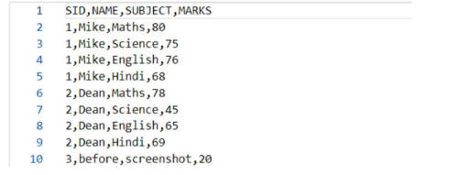

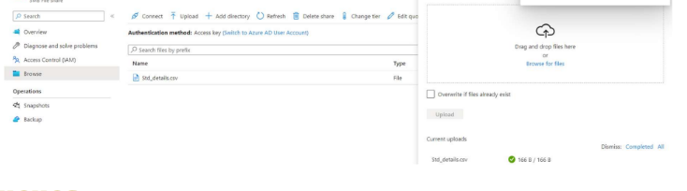

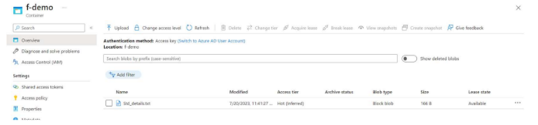

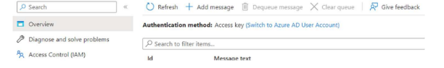

Azure Active Directory Integration for authorizing access to blob, queue, and table resources

Microsoft recommends using Azure AD Credentials to authorize request to data when possible, for optimal security and ease of use

We can use Azure Role based access control to manage the security principle permission to blob, queue, and table resources in the storage account

Exercise – 2

Creating Access Keys

Step 1: Create Storage Account

Step 2: Access Keys Options for Storage Account

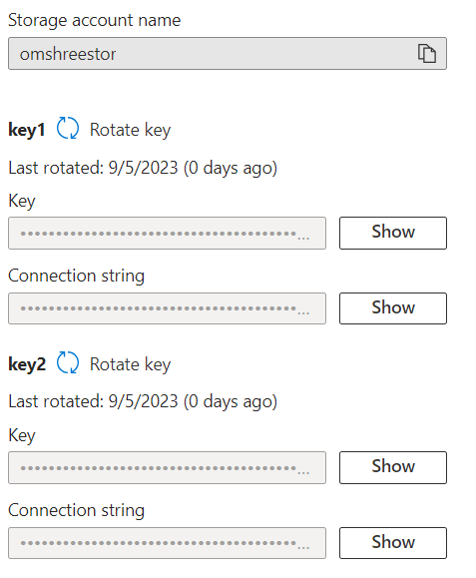

Rotate Key to Generate Key

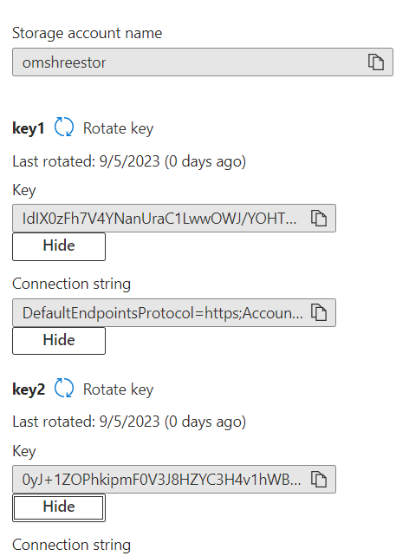

Shared Access Signatures

Granting Access to services and setting the expiration date

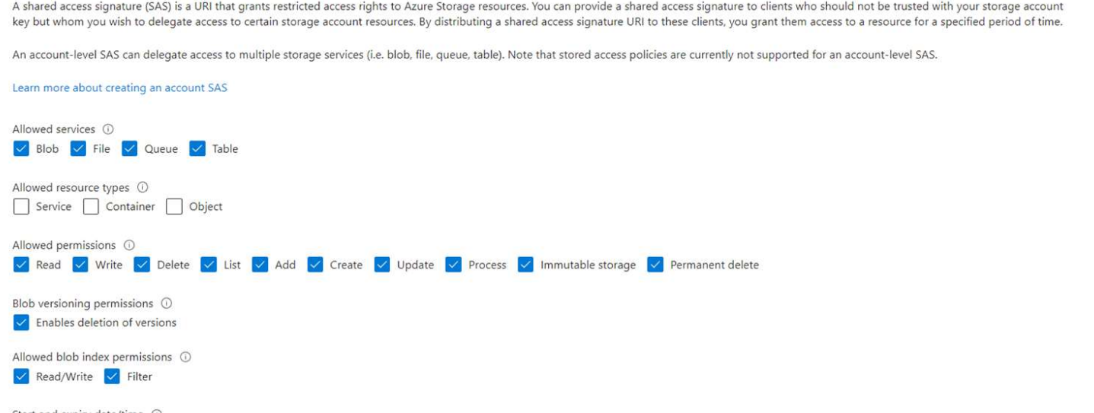

Generating SAS

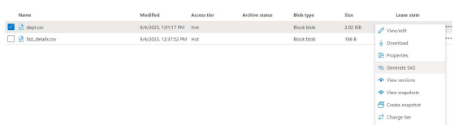

Using the BLOB link to download file from explorer

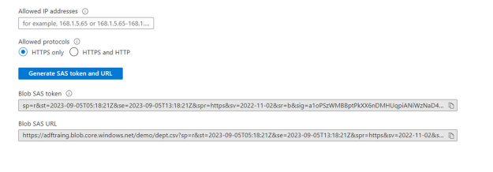

Exercise 3: Creating Azure Data Factories

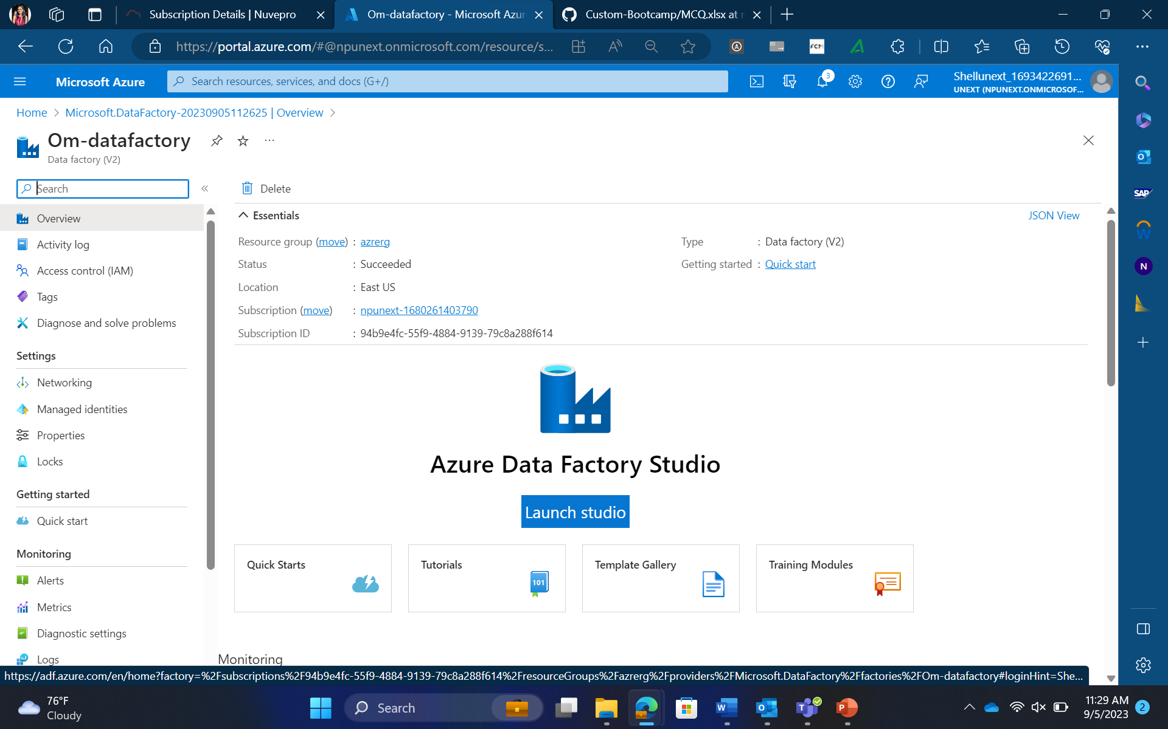

Launch Studio on Azure Data Factory

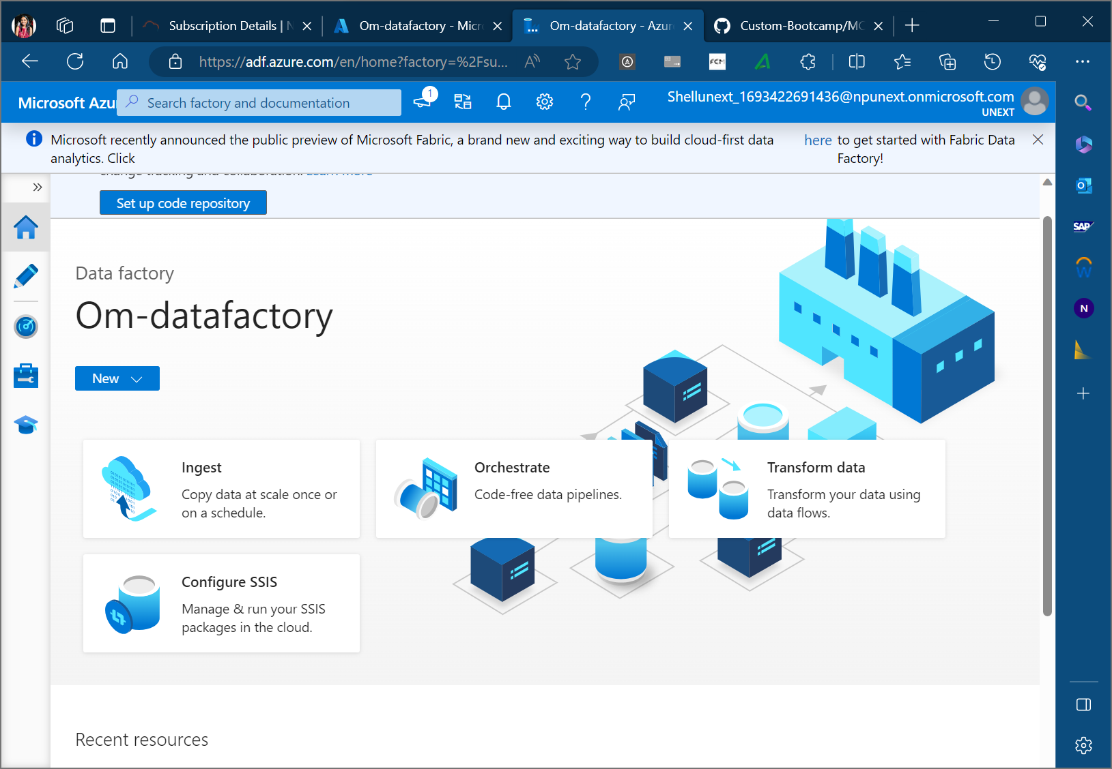

Creating Pipeline

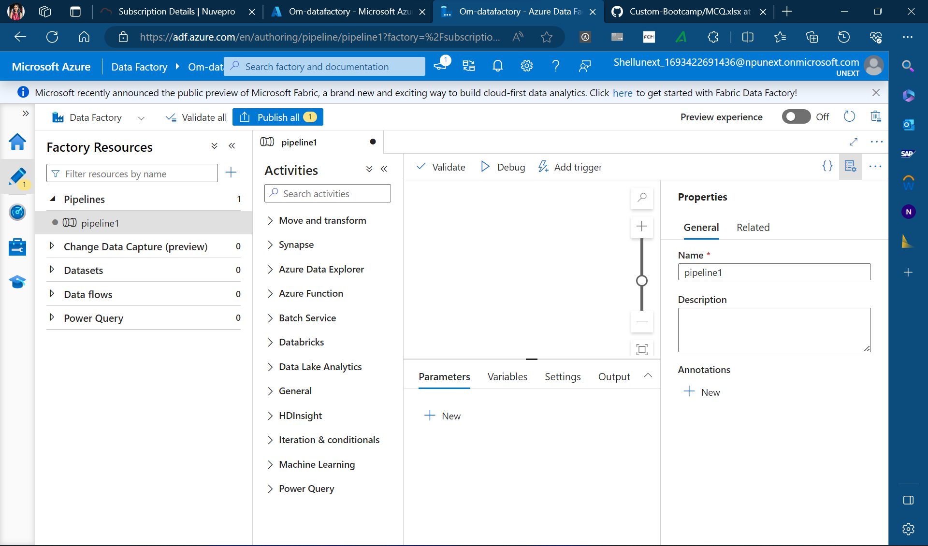

Dataflow from previously uploaded data in storage

